**Assignment 2**

create database sales

create table salesman(salesman_id int primary key, name varchar(50), city varchar(30),commision float)

insert into salesman values(5001, 'James Hoog', 'New York', 0.15)

insert into salesman values(5002, 'Nail Knite', 'Paris', 0.13)

insert into salesman values(5005, 'Pit Alex', 'London', 0.11)

insert into salesman values(5006, 'Mc Lyon', 'Paris', 0.14)

insert into salesman values(5007, 'Paul Adam', 'Rome', 0.13)

insert into salesman values(5003, 'Lauson Hen', 'San Jose', 0.12)

create table customer(customer_id int primary key, cust_name varchar(50), city varchar(30),grade int,salesman_id int foreign key REFERENCES salesman(salesman_id))

insert into customer values(3002, 'Nick Rimando', 'New York', 100, 5001)

insert into customer values(3007, 'Brad Davis', 'New York', 200, 5001)

insert into customer values(3005, 'Graham Zusi', 'California', 200, 5002)

insert into customer values(3008, 'Julian Green', 'London', 300, 5002)

insert into customer values(3004, 'Fabian Johnson', 'Paris', 300, 5006)

insert into customer values(3009, 'Geoff Cameron', 'Berlin', 100, 5003)

insert into Customer values(3003, 'Jozy Altidor', 'Moscow', 200, 5007)

insert into Customer values(3001, 'Brad Guzan', 'London', NULL, 5005)

create table orders(

order_no numeric(5) primary key, purch_amt decimal(8,2), order_date date,

customer_id int foreign key references customer(customer_id), salesman_id int foreign key references salesman(salesman_id))

insert into orders values(70001, 150.5, '2012-10-05', 3005, 5002)

insert into orders values(70009, 270.65, '2012-09-10', 3001, 5005)

insert into orders values(70002, 65.26, '2012-10-05', 3002, 5001)

insert into orders values(70004, 110.5, '2012-08-17', 3009, 5003)

insert into orders values(70007, 948.5, '2012-09-10', 3005, 5002)

insert into orders values(70005, 2400.6, '2012-07-27', 3007, 5001)

insert into orders values(70008, 5760, '2012-09-10', 3002, 5001)

insert into orders values(70010, 1983.43, '2012-10-10', 3004, 5006)

insert into orders values(70003, 2480.4, '2012-10-10', 3009, 5003)

insert into orders values(70012, 250.45, '2012-06-27', 3008, 5002)

insert into orders values(70011, 75.29, '2012-08-17', 3003, 5007)

insert into orders values(70013, 3045.6, '2012-04-25', 3002, 5001)

select * from salesman;

select * from customer;

select * from orders;

**1. write a SQL query to find the salesperson and customer who reside in the same city.**

**Return Salesman, cust_name and city.**

select [name],cust_name,salesman.city from salesman inner join customer

on customer.city = salesman.city

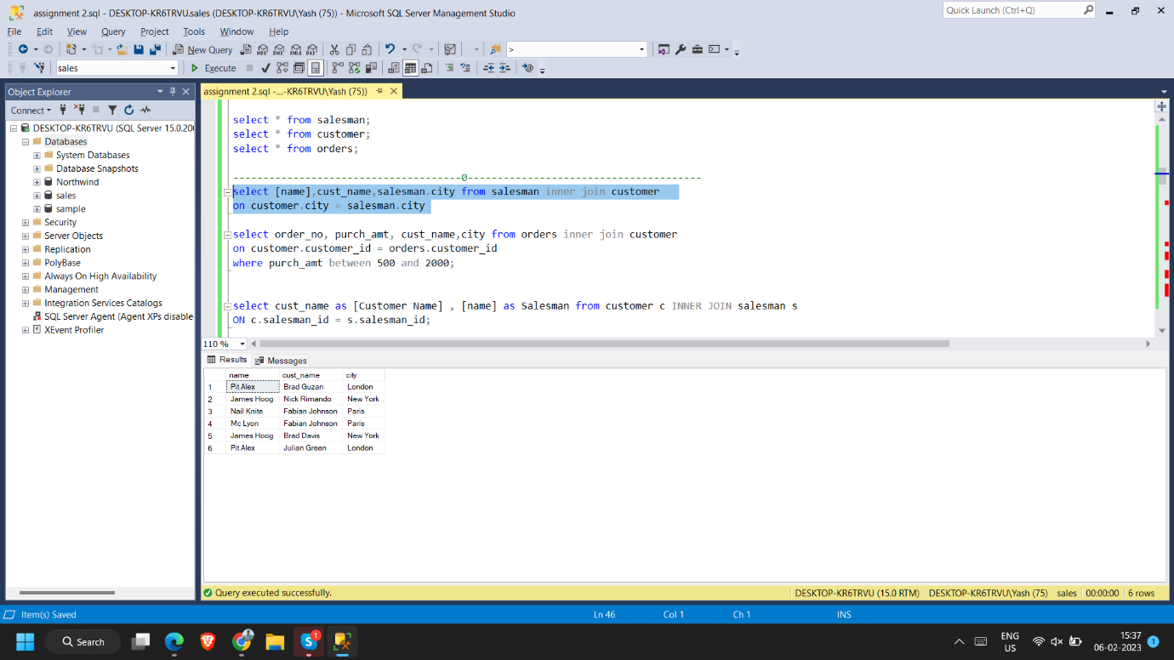

**2. write a SQL query to find those orders where the order amount exists between 500**

**and 2000. Return ord_no, purch_amt, cust_name, city**

select order_no, purch_amt, cust_name,city from orders inner join customer

on customer.customer_id = orders.customer_id

where purch_amt between 500 and 2000;

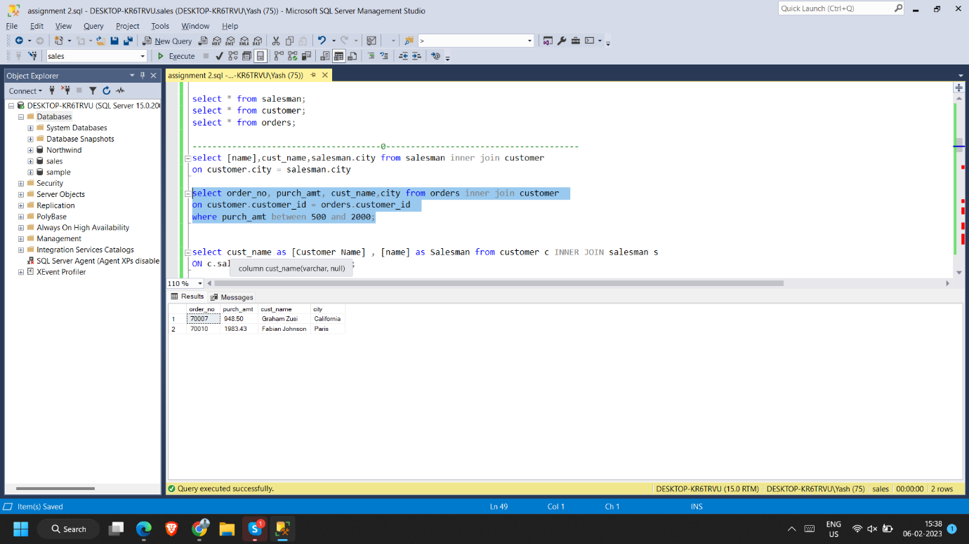

**3. write a SQL query to find the salesperson(s) and the customer(s) he represents.**

**Return Customer Name, city, Salesman, commission**

select cust_name as [Customer Name] , [name] as Salesman from customer c INNER JOIN salesman s

ON c.salesman_id = s.salesman_id;

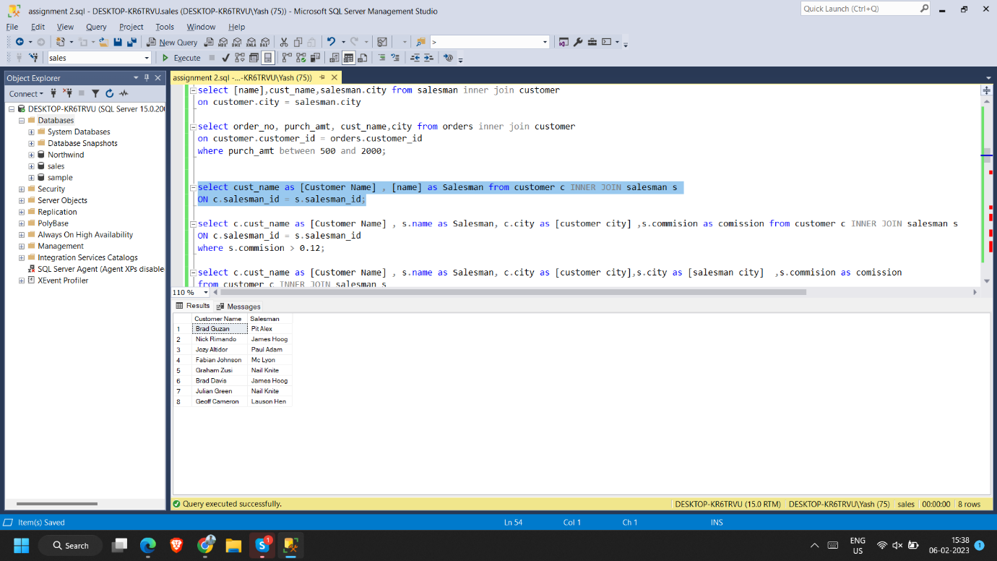

**4. write a SQL query to find salespeople who received commissions of more than 12**

**percent from the company. Return Customer Name, customer city, Salesman,**

**commission.**

select c.cust_name as [Customer Name] , s.name as Salesman, c.city as [customer city] ,s.commision as comission from customer c INNER JOIN salesman s

ON c.salesman_id = s.salesman_id

where s.commision > 0.12**;**

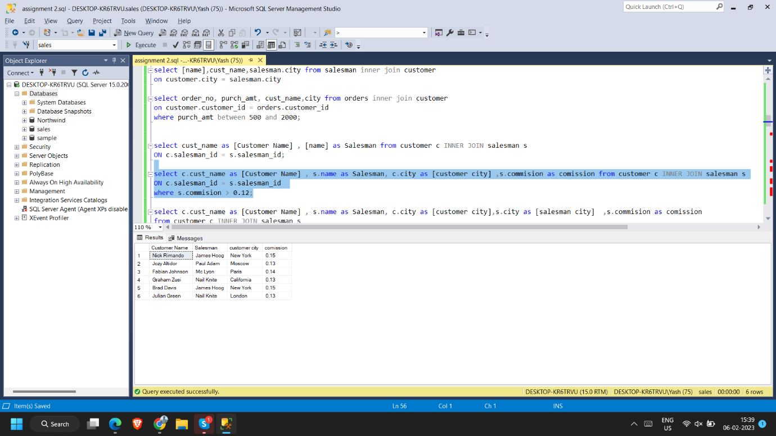

**5. write a SQL query to locate those salespeople who do not live in the same city where**

**their customers live and have received a commission of more than 12% from the**

**company. Return Customer Name, customer city, Salesman, salesman city,**

**commission**

select c.cust_name as [Customer Name] , s.name as Salesman, c.city as [customer city],s.city as [salesman city] ,s.commision as comission

from customer c INNER JOIN salesman s

ON c.salesman_id = s.salesman_id

where s.commision > 0.12 and c.city != s.city;

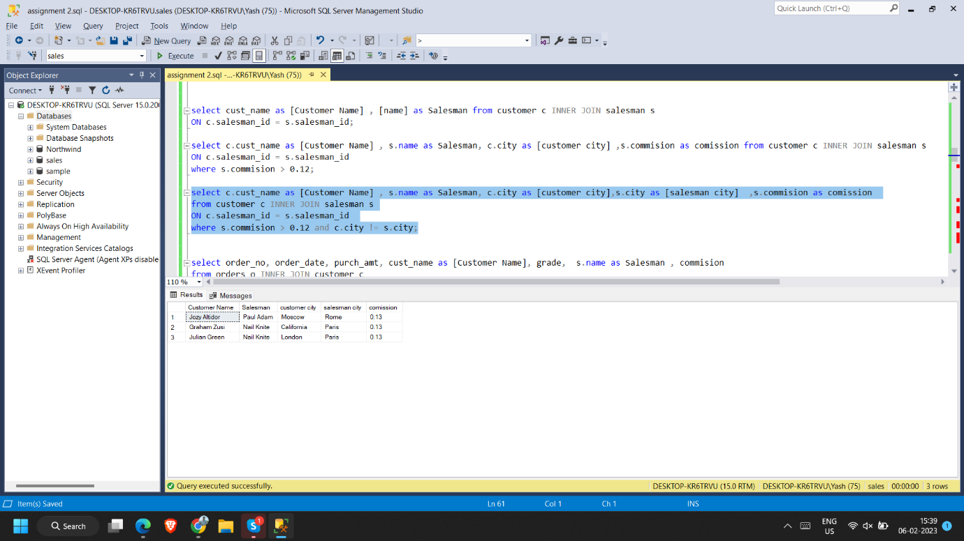

**6. write a SQL query to find the details of an order. Return ord_no, ord_date,**

**purch_amt, Customer Name, grade, Salesman, commission**

select order_no, order_date, purch_amt, cust_name as [Customer Name], grade, s.name as Salesman , commision

from orders o INNER JOIN customer c

ON o.customer_id=c.customer_id

INNER JOIN salesman s ON o.salesman_id=s.salesman_id;

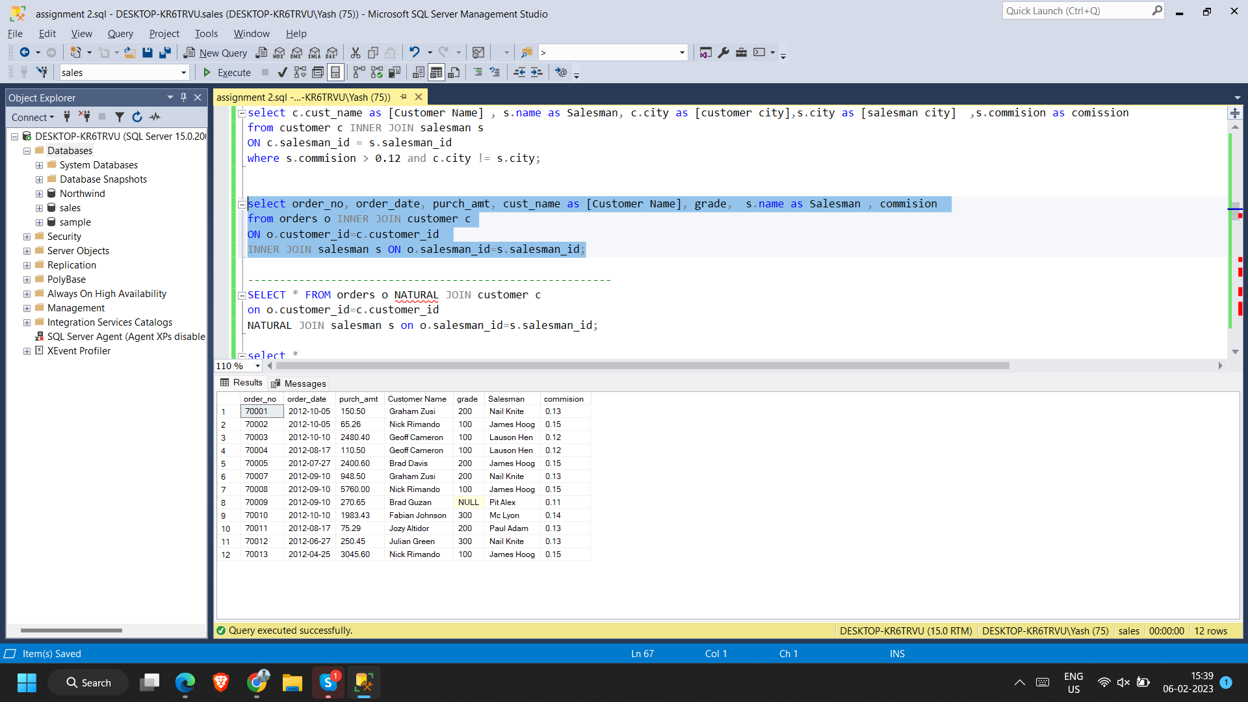

**7. Write a SQL statement to join the tables salesman, customer and orders so that the**

**same column of each table appears once and only the relational rows are returned.**

select o.order_no, o.purch_amt, o.customer_id, c.cust_name, c.city, c.grade, o.salesman_id, s.[name], s.city, s.commision

from orders o

join customer c on o.customer_id = c.customer_id

join salesman s on o.salesman_id = s.salesman_id;

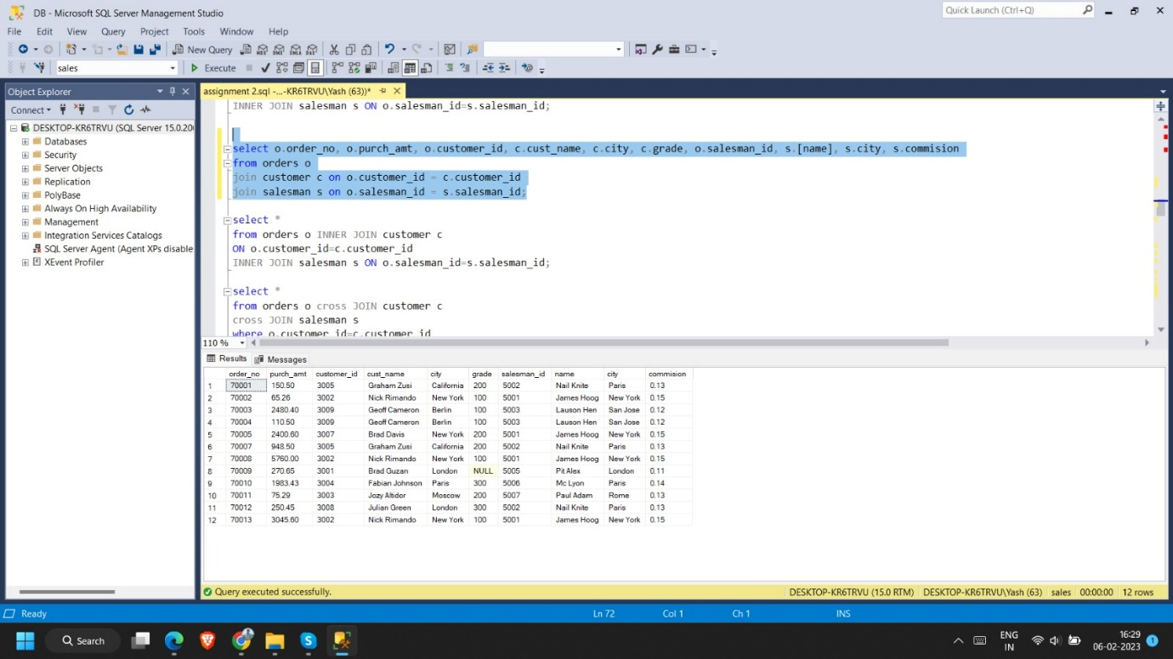

**8. write a SQL query to display the customer name, customer city, grade, salesman,**

**salesman city. The results should be sorted by ascending customer_id.**

select c.cust_name as [Customer Name] ,c.city as [customer city] , s.name as Salesman, s.city as [salesman city],c.grade

from customer c inner JOIN salesman s

ON c.salesman_id = s.salesman_id

order by c.customer_id asc ;

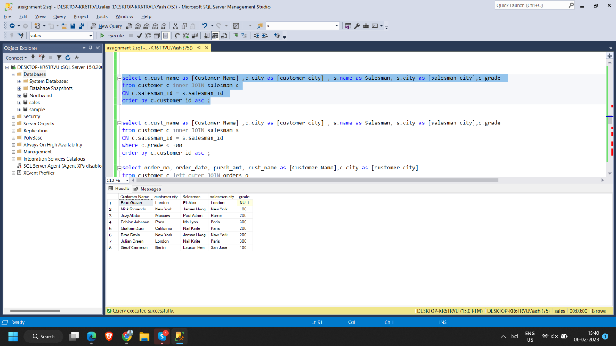

**9. write a SQL query to find those customers with a grade less than 300. Return**

**cust_name, customer city, grade, Salesman, salesmancity. The result should be**

**ordered by ascending customer_id.**

select c.cust_name as [Customer Name] ,c.city as [customer city] , s.name as Salesman, s.city as [salesman city],c.grade

from customer c inner JOIN salesman s

ON c.salesman_id = s.salesman_id

where c.grade < 300

order by c.customer_id asc ;

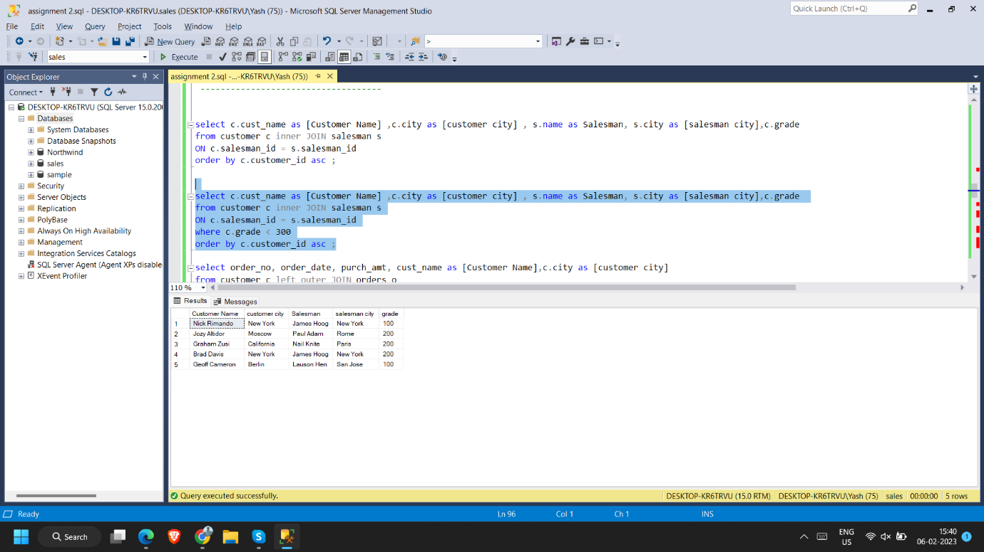

**10. Write a SQL statement to make a report with customer name, city, order number,**

**order date, and order amount in ascending order according to the order date to**

**determine whether any of the existing customers have placed an order or not**

select order_no, order_date, purch_amt, cust_name as [Customer Name],c.city as [customer city]

from customer c left outer JOIN orders o

ON c.customer_id = o.customer_id

order by o.order_date asc ;

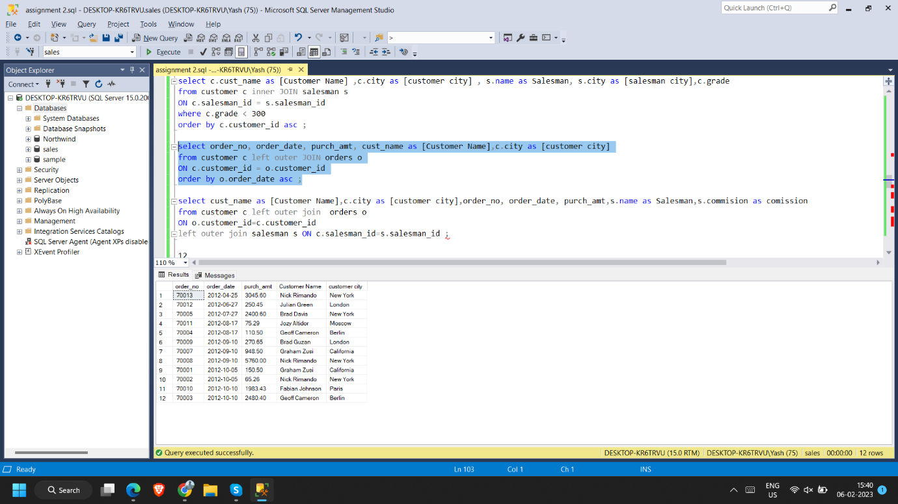

**11. Write a SQL statement to generate a report with customer name, city, order number,**

**order date, order amount, salesperson name, and commission to determine if any of**

**the existing customers have not placed orders or if they have placed orders through**

**their salesman or by themselves**

select cust_name as [Customer Name],c.city as [customer city],order_no, order_date, purch_amt,s.name as Salesman,s.commision as comission

from customer c left outer join orders o

ON o.customer_id=c.customer_id

left outer join salesman s ON c.salesman_id=s.salesman_id ;

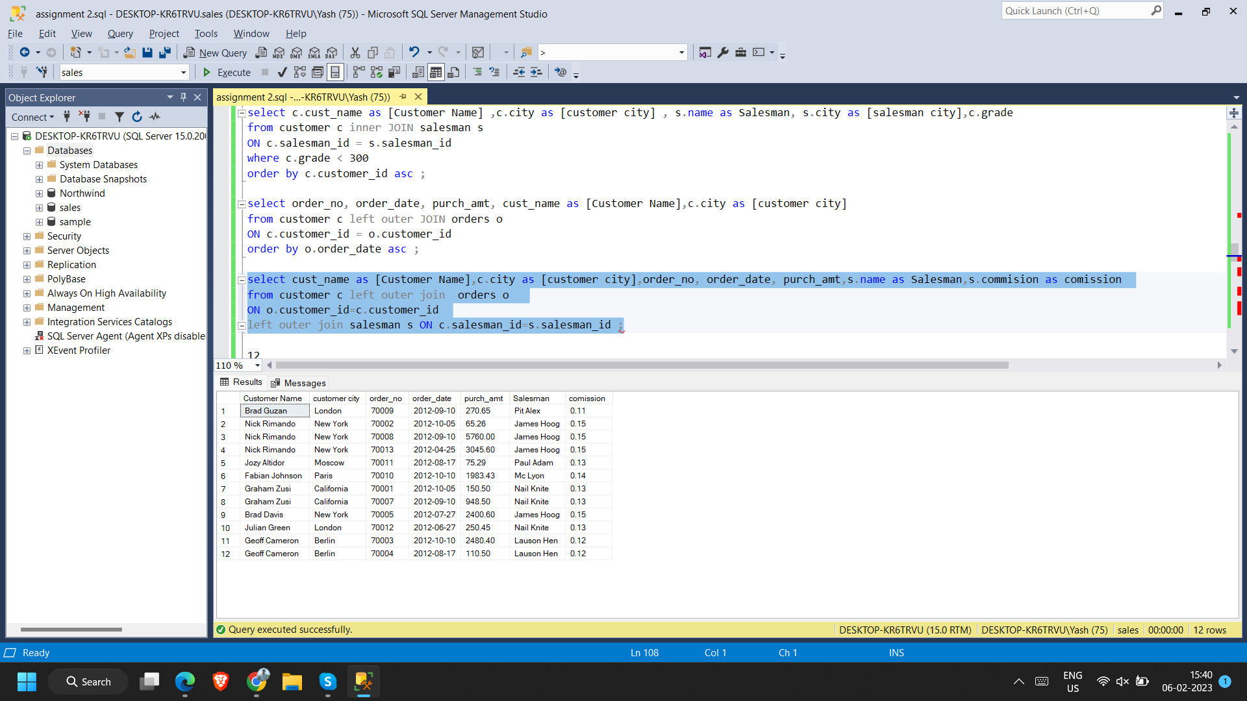

**12. Write a SQL statement to generate a list in ascending order of salespersons who**

**work either for one or more customers or have not yet joined any of the customers**

select count(name) as oder,s.name from customer c right outer join salesman s

ON s.salesman_id=c.salesman_id

group by s.name

order by oder

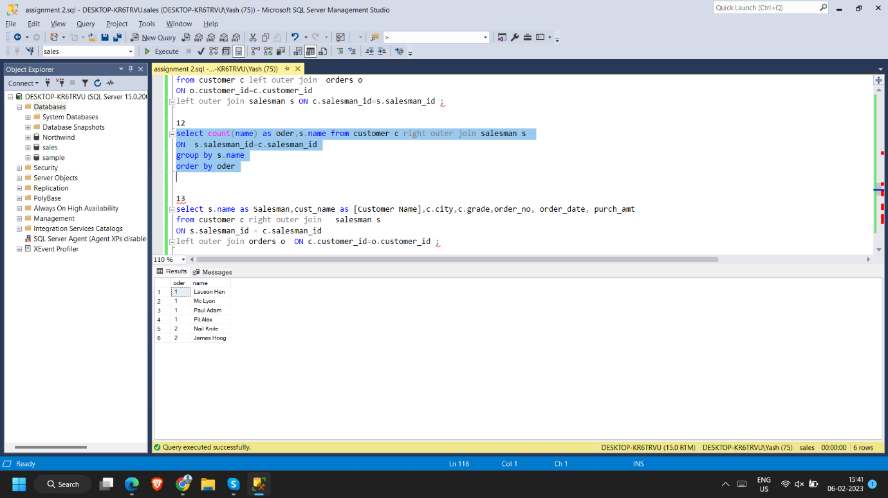

**13. write a SQL query to list all salespersons along with customer name, city, grade,**

**order number, date, and amount.**

select s.name as Salesman,cust_name as [Customer Name],c.city,c.grade,order_no, order_date, purch_amt

from customer c right outer join salesman s

ON s.salesman_id = c.salesman_id

left outer join orders o ON c.customer_id=o.customer_id ;

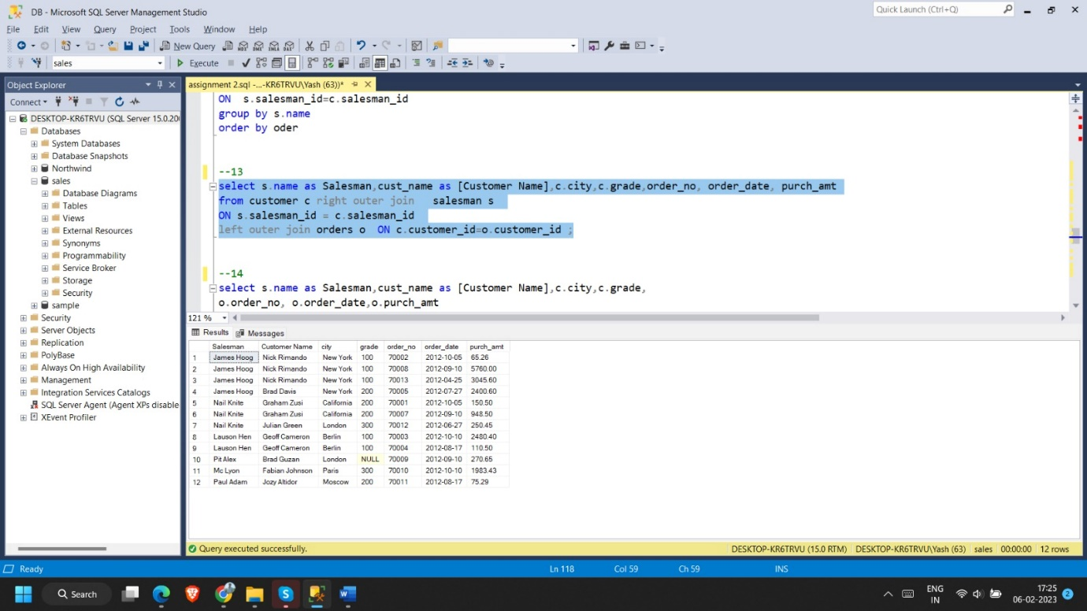

**14. Write a SQL statement to make a list for the salesmen who either work for one or**

**more customers or yet to join any of the customers. The customer may have placed,**

**either one or more orders on or above order amount 2000 and must have a grade, or**

**he may not have placed any order to the associated supplier.**

select s.name as Salesman,cust_name as [Customer Name],c.city,c.grade,

o.order_no, o.order_date,o.purch_amt

from customer c right outer join salesman s

ON c.salesman_id=s.salesman_id

left outer join orders o ON c.customer_id=o.customer_id

where o.purch_amt > 2000 and grade is not null

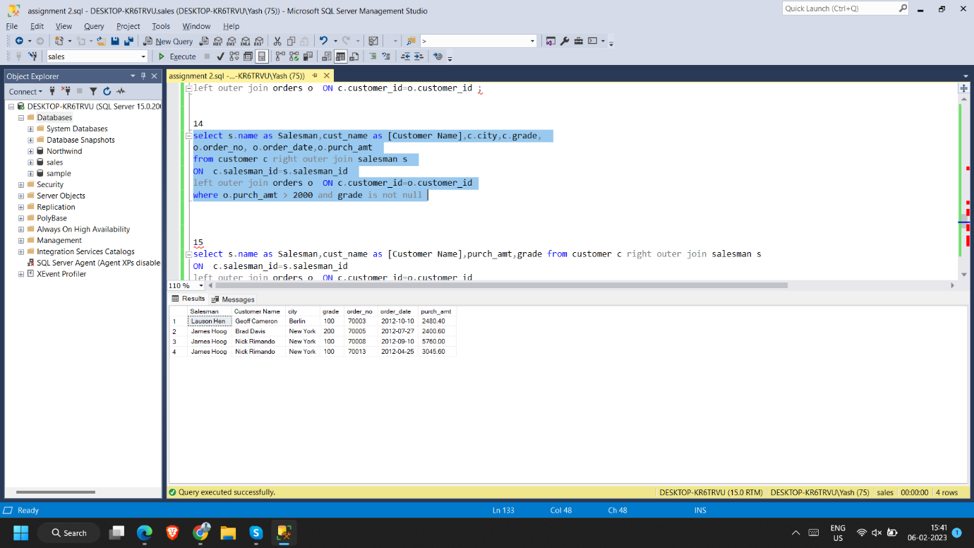

**15. Write a SQL statement to generate a list of all the salesmen who either work for one**

**or more customers or have yet to join any of them. The customer may have placed**

**one or more orders at or above order amount 2000, and must have a grade, or he**

**may not have placed any orders to the associated supplier.**

select s.name as Salesman,cust_name as [Customer Name],purch_amt,grade from customer c right outer join salesman s

ON c.salesman_id=s.salesman_id

left outer join orders o ON c.customer_id=o.customer_id

where o.purch_amt > 2000 and grade is not null ;

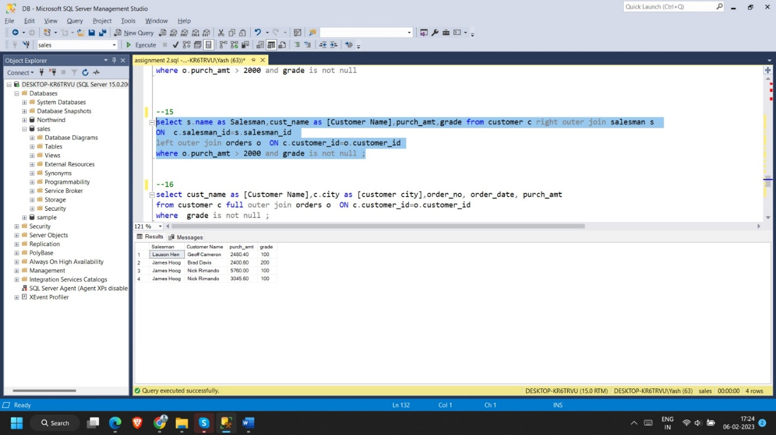

**16. Write a SQL statement to generate a report with the customer name, city, order no.**

**order date, purchase amount for only those customers on the list who must have a**

**grade and placed one or more orders or which order(s) have been placed by the**

**customer who neither is on the list nor has a grade.**

select cust_name as [Customer Name],c.city as [customer city],order_no, order_date, purch_amt

from customer c full outer join orders o ON c.customer_id=o.customer_id

where grade is not null ;

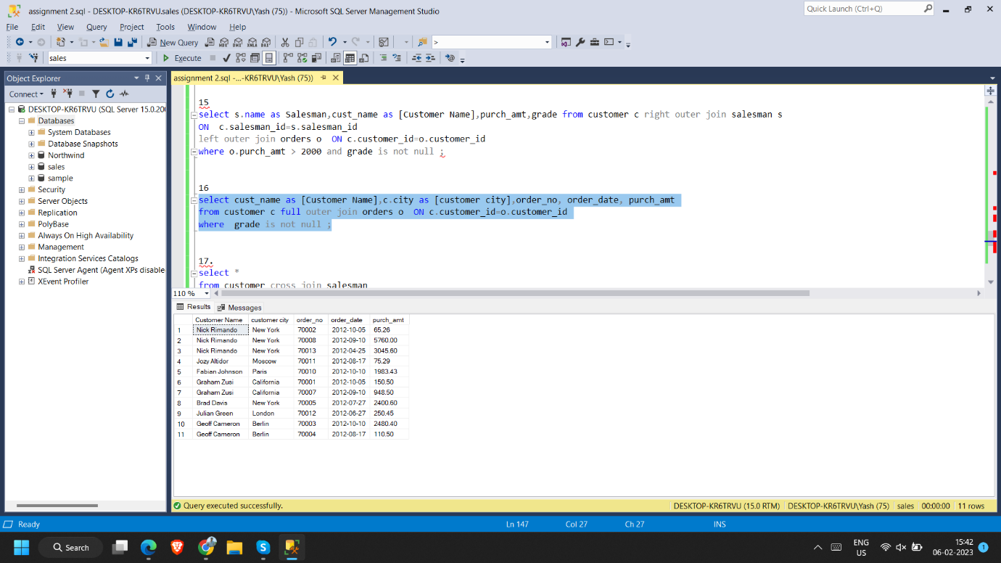

**17. Write a SQL query to combine each row of the salesman table with each row of the**

**customer table**

select *

from customer cross join salesman

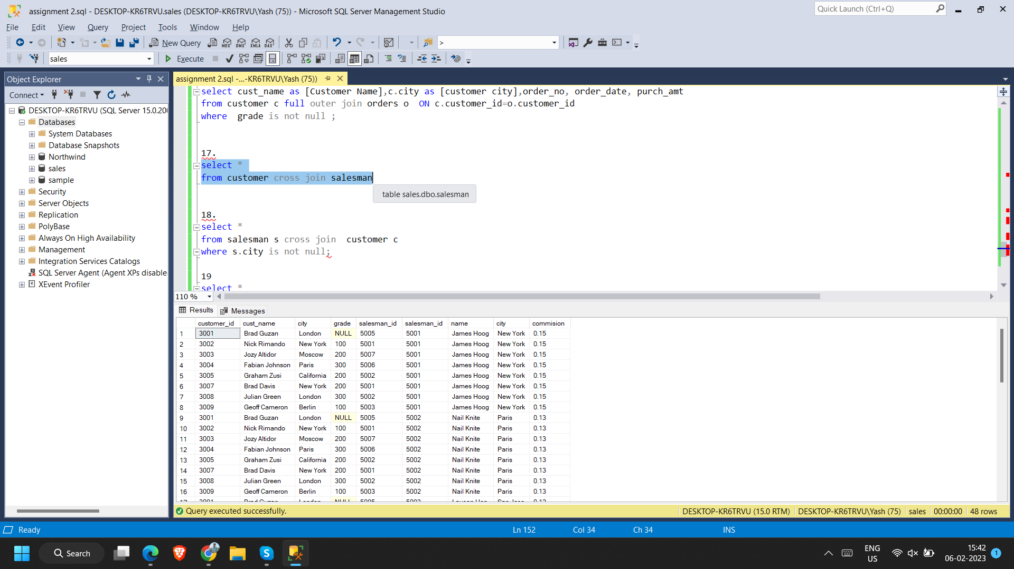

**18. Write a SQL statement to create a Cartesian product between salesperson and**

**customer, i.e. each salesperson will appear for all customers and vice versa for that**

**salesperson who belongs to that city**

select *

from salesman s cross join customer c

where s.city is not null;

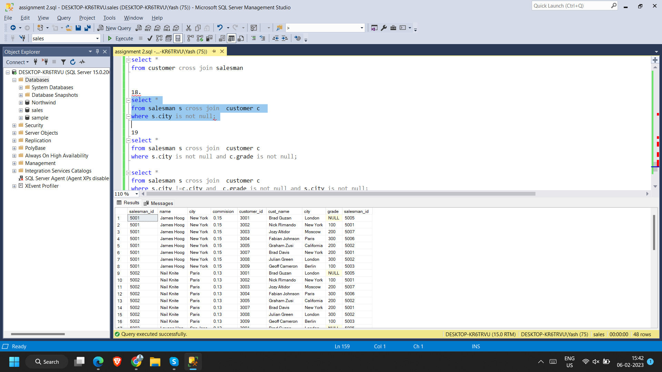

**19. Write a SQL statement to create a Cartesian product between salesperson and**

**customer, i.e. each salesperson will appear for every customer and vice versa for**

**those salesmen who belong to a city and customers who require a grade**

select *

from salesman s cross join customer c

where s.city is not null and c.grade is not null;

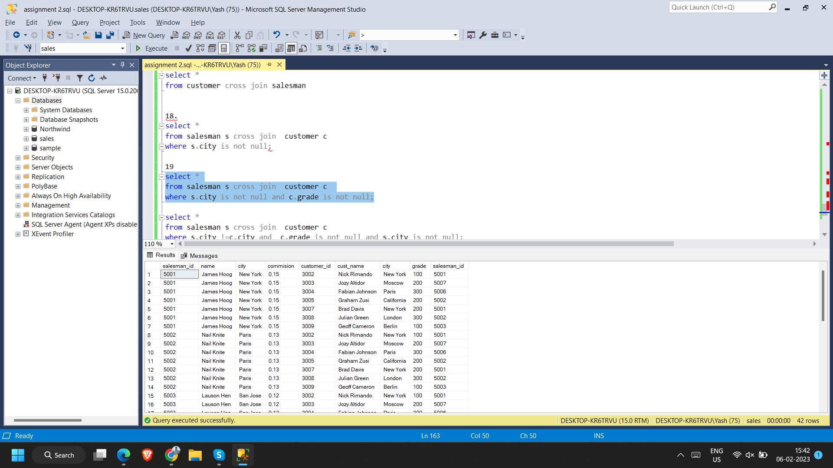

**20. Write a SQL statement to make a Cartesian product between salesman and**

**customer i.e. each salesman will appear for all customers and vice versa for those**

**salesmen who must belong to a city which is not the same as his customer and the**

**customers should have their own grade**

select *

from salesman s cross join customer c

where s.city !=c.city and c.grade is not null and s.city is not null;

